**LAB 4 Advanced Software Engineering**

**Android App with WEB VIEW using soap services.**

The mobile client and the soap service developed were used to develop the android app using Android SDK.

The android sdk was downloaded from internet, installed and opened to create a new android project ‘stringcount’. Following the tutorial the android project was created and a web view was added to it as shown: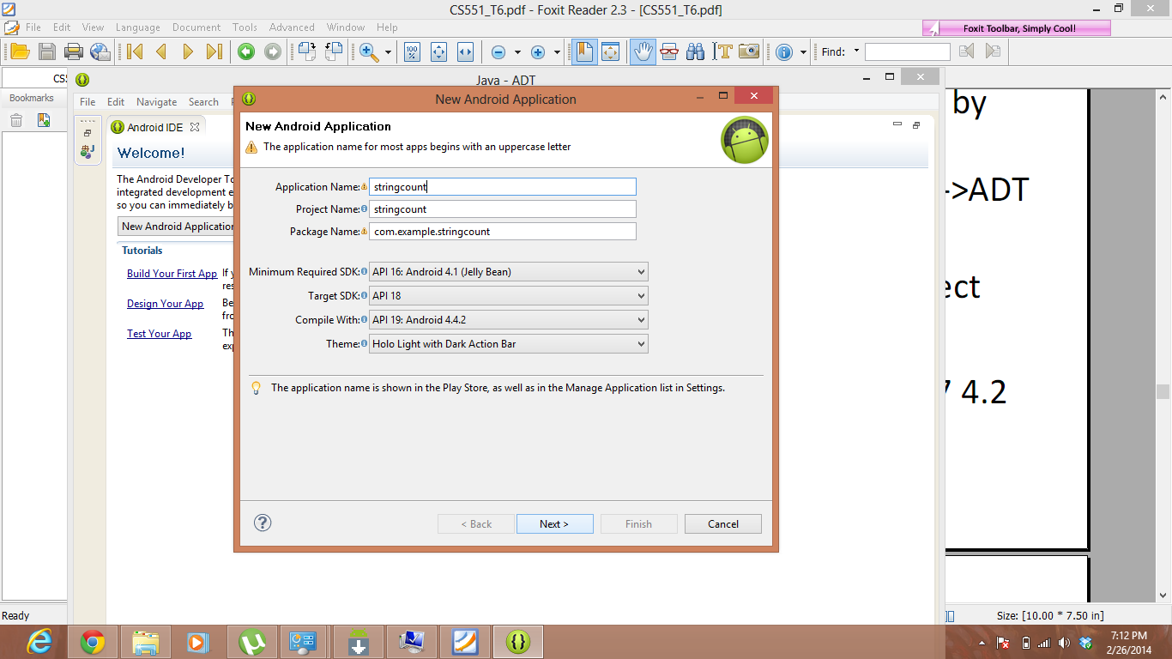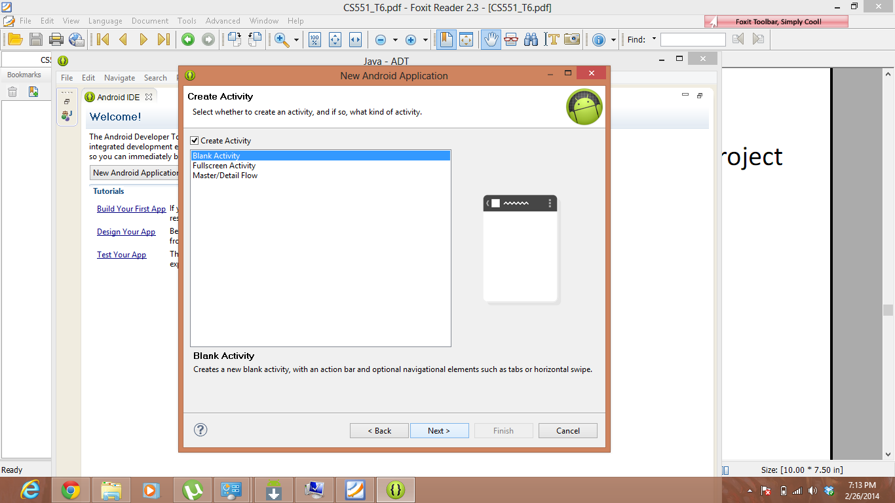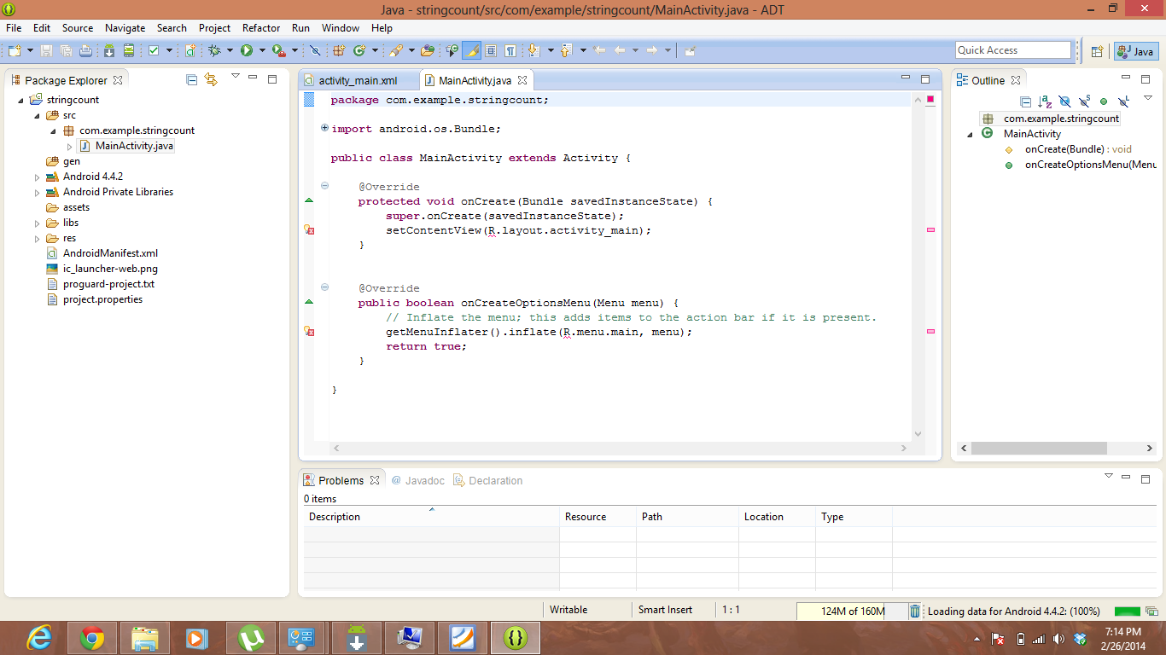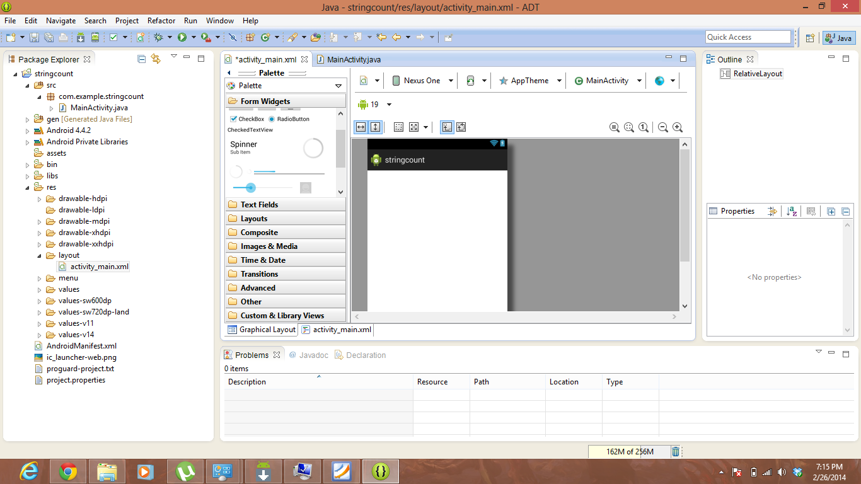

A web view is added here in the android app.

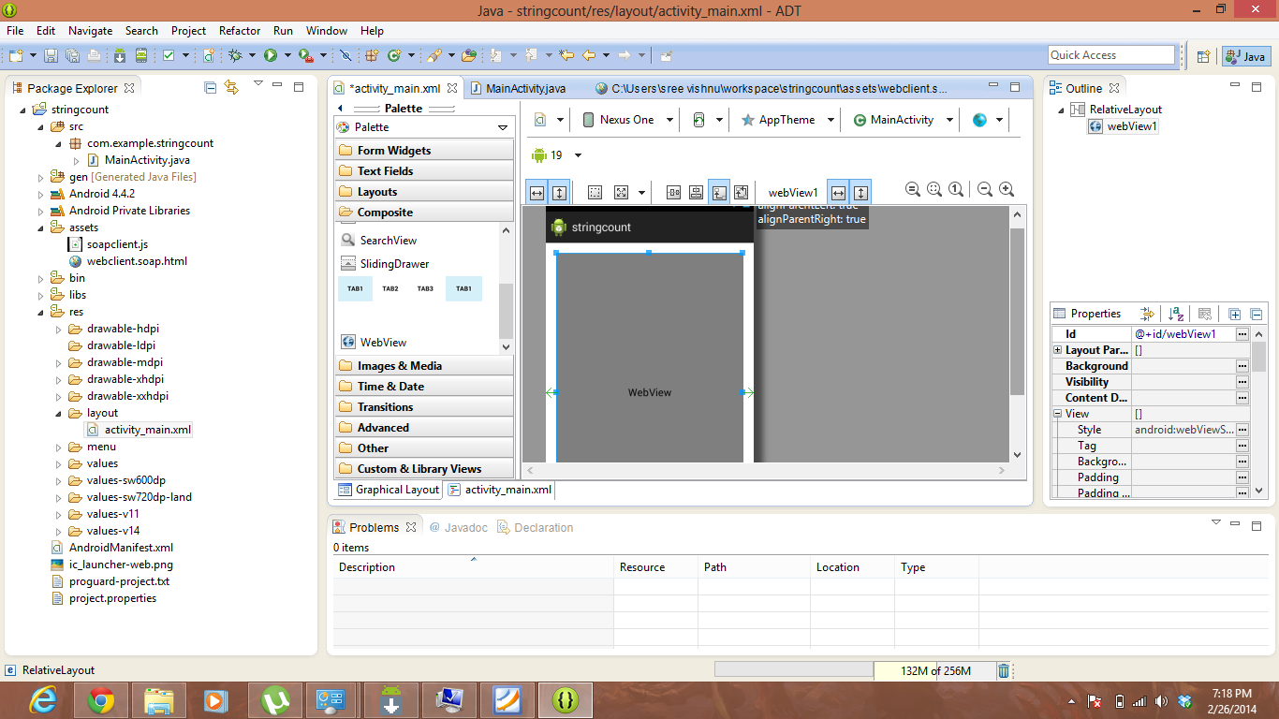

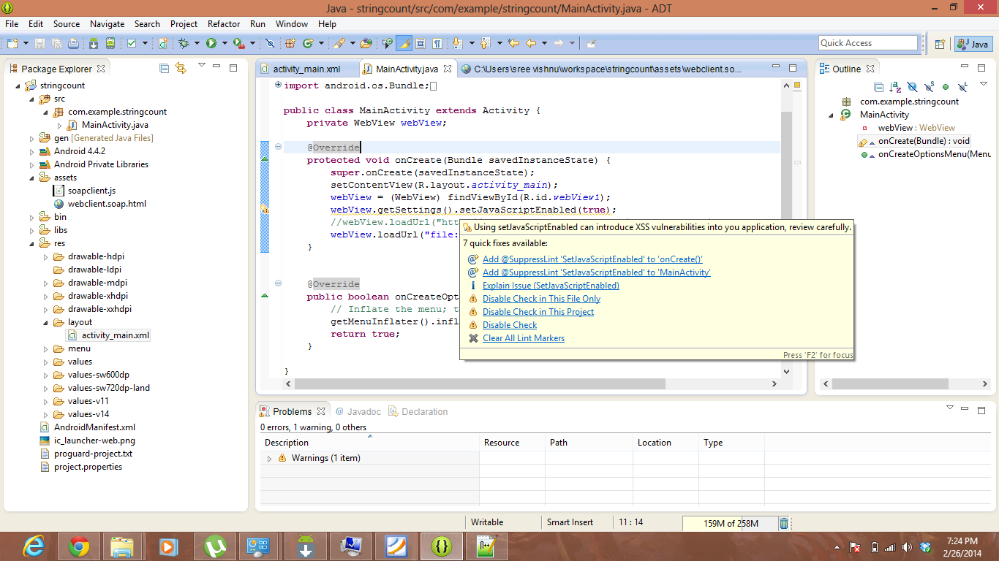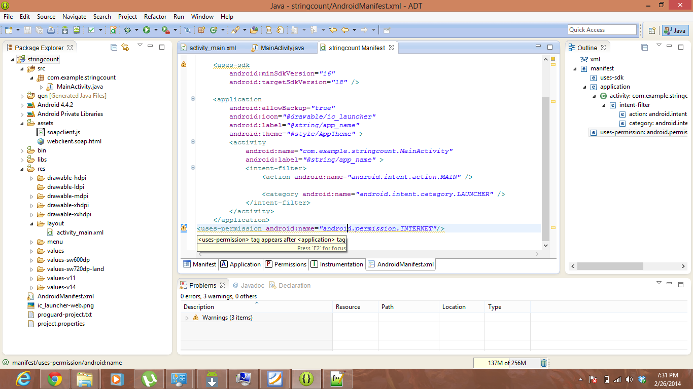

Application was run using the android emulator as shown.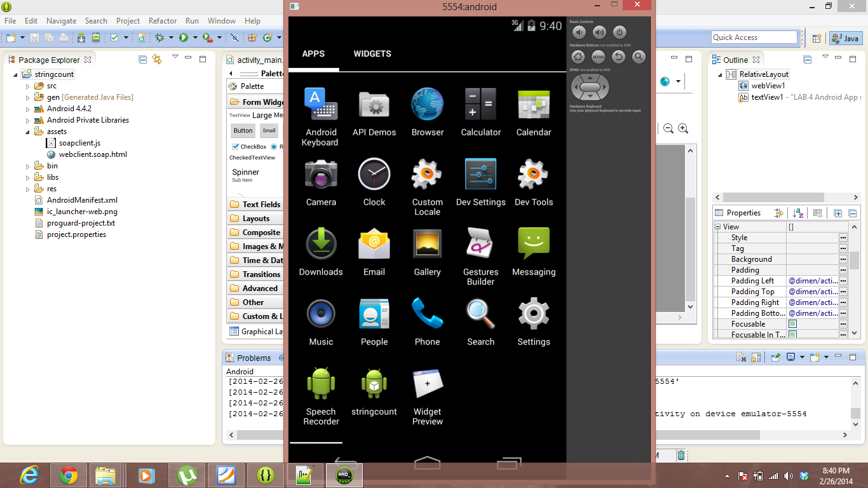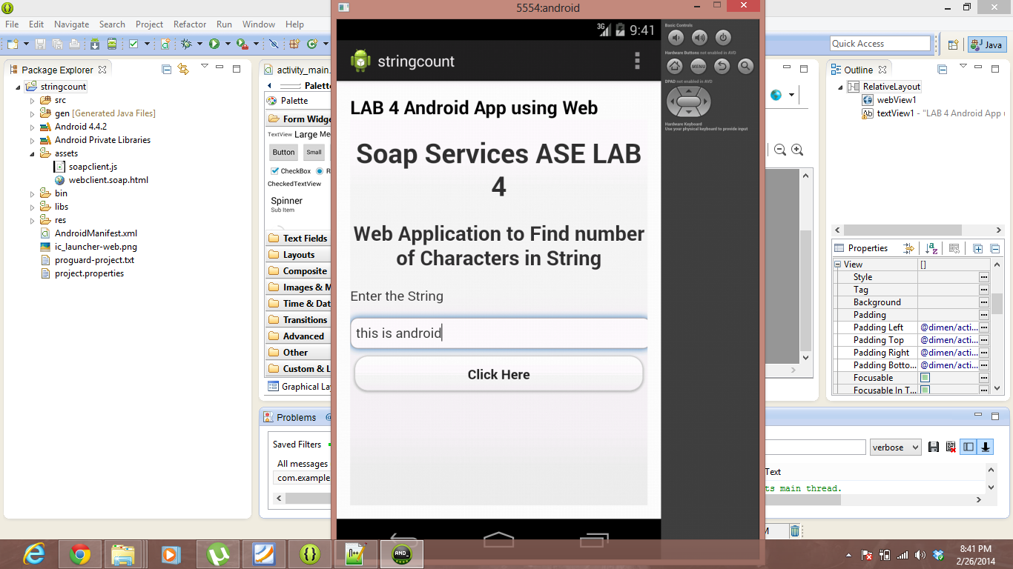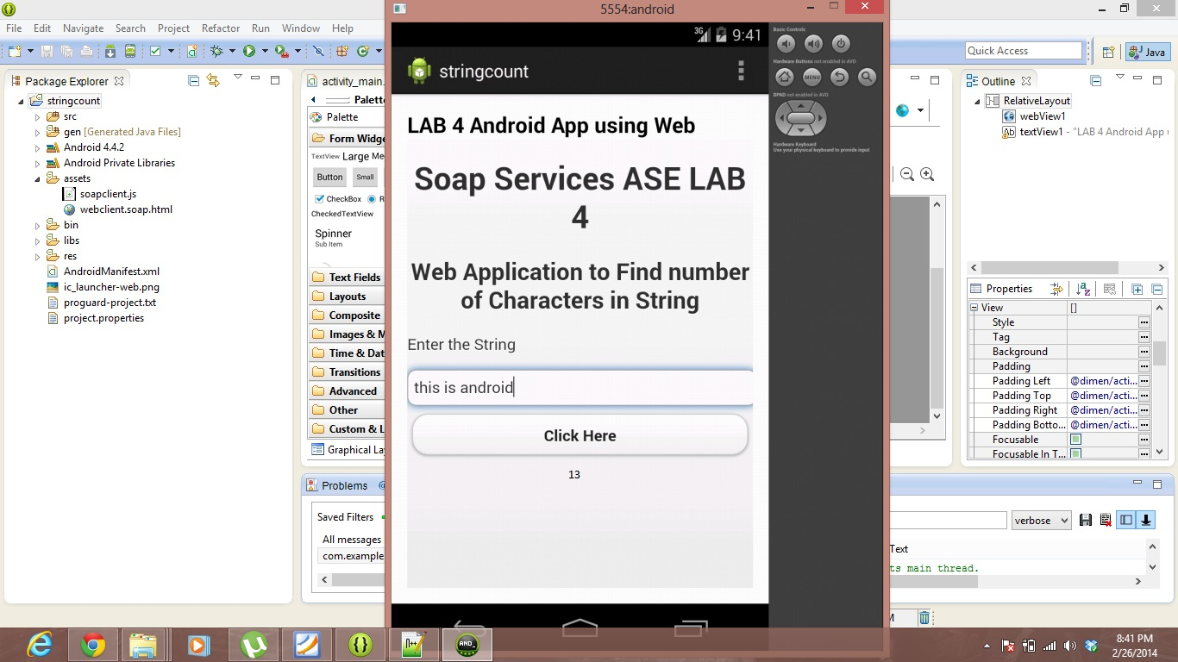

The string “this is android” is entered in the text box and the button is clicked to get the result which is shown just below the button.